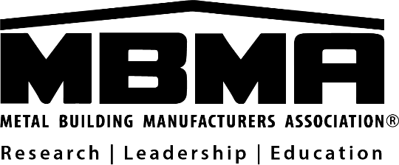

APPLICATION FOR ASSOCIATE MEMBERSHIP

We wish to become an Associate member of the METAL BUILDING MANUFACTURERS ASSOCIATION. The following information is submitted in support of our application:

COMPANY NAME:

COMPANY ADDRESS:

PHONE: WEBSITE:

INDIVIDUAL: PARTNERSHIP: CORPORATION:

CHIEF EXECUTIVE OFFICER:

PRESIDENT: (If different from CEO)

PRIMARY CONTACT PERSON FOR ALL ASSOCIATION CORRESPONDENCE

NAME:

TITLE:

ADDRESS:

PHONE:

EMAIL:

Our company first started to manufacture products and/or provide services sold to metal building systems manufacturers (as defined in Article III, Section 3 of the Bylaws) in (Year).

Our company currently manufactures the following products or provides the following services to companies engaged in the metal building systems industry (check all that apply):

Steel Mill Doors & Windows
Steel Service Center Vents, Louvers & Curbs
Testing, Inspection or Certification Fasteners & Bolts
Coil Coaters (Paint) Insulation/Ceilings
Coating Manufacturers Sealants/Adhesives
Other (please specify) Joists

We hereby certify that we fall into the following dues category based on our firm’s previous year sales to the entire metal building systems industry. Please check the appropriate category. (Dues are prorated based on the month a company becomes an associate member.)

Category I - More than $10 million
$16,800 annual dues

Category II - $6 million to $10 million
$11,200 annual dues

Category III - $2 million to $6 million
$5,600 annual dues

Category IV - Less than $2 million
$2,800 annual dues

Category V – Testing Laboratory, Accredited Inspection Agency, A/E Firm, Consulting Firm
$1,120 annual dues

Business Unit Category - $1,120 per unit
(The corporate entity with the highest shipments to the industry is to hold the full associate membership. All smaller entities within that corporate organization who wish to hold a separate associate membership in MBMA will hold business unit memberships.)

We have read the Bylaws and do meet the requirements for Associate membership as set forth in Article III, Section 3. We do not meet the requirements for metal building manufacturer members. We agree to pay all dues and assessments properly approved by the Board of Directors, and to pay all expenses including reasonable attorney’s fees that are incurred by MBMA because of our failure to pay such dues and assessments.

We understand that usage of the MBMA Logo is only permitted and pursuant to a Licensing Agreement which will be provided for signature upon acceptance of our membership application.

We agree to be governed by the Bylaws of the METAL BUILDING MANUFACTURERS ASSOCIATION and to submit data on shipments for the confidential use of the General Manager in assessing dues.

SIGNATURE:

TYPED NAME:

TITLE:

DATE:

Return completed application to mbma@mbma.com

